**DAILY ONLINE ACTIVITIES SUMMARY**

|  |  |  |  |  |  |  |  |
| --- | --- | --- | --- | --- | --- | --- | --- |
| **Date:** | | **3/6/2020** | | | | | |
| **Name of the Faculty** | | **REENA LOBO** | | | | | |
| **No. of Students Allotted for monitoring** | | | | | **19** | | |
| **Progress** | | | | | **GOOD** | | |
| **Whether collected report from all the allotted students** | | | | | **18,NOT SUBMITTED RAMITHA** | | |
| **Online Test Summary** | | | | | | | |
| **Subject** |  | | | | | | |
| **Semester** |  | | | **Duration** | |  | |
| **No. of students Taken** | | |  | **Passing %** | |  | |
| **Certification Course Summary** | | | | | | | |
| **Course** | | 1.attended **Webinar:python programming,**  **Certification provider: SJBIT COLLEGE**  **Duration:1hr.**  **2.participated in data mining and warehousing quiz** | | | | | |
| **Certificate Provider** | |  | | | **Duration** | |  |
| **Coding Challenges** | | | | | | | |
| **Problem statement: Write a code segment in java to swap two numbers using call by object reference.**  **Language used for solving: JAVA**  **Whether posted in Github: YES**  **Link:** <https://github.com/orgs/alvas-education-foundation/teams/2nd-year/discussions/98> | | | | | | | |
| **Status: COMPLETED** | | | | | | | |
| **Uploaded the report in Github** | | | | | **yes** | | |
| **If yes Repository name** | | | | | <https://github.com/reenalobo/ONLINE-ACTIVITY-REPORT/upload/master> | | |
| **Uploaded the report in slack** | | | | | **yes** | | |

Certification Course Details: (Attach the snapshot and briefly write the report for the same)

**Webinar:python programming,SJBIT COLLEGE**

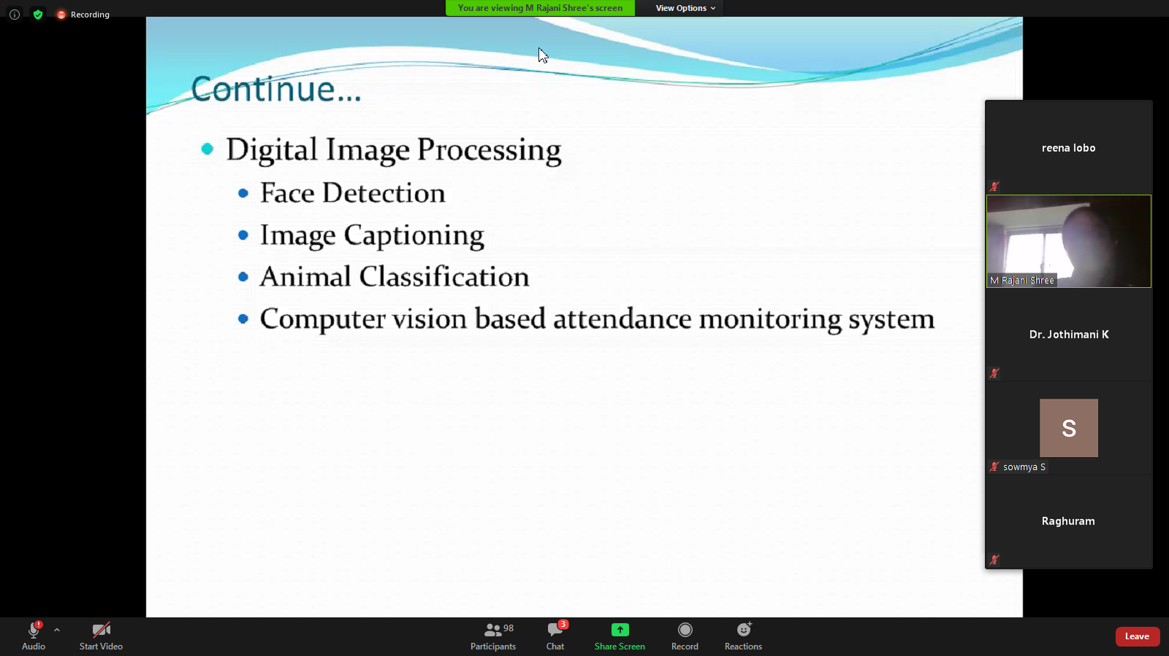

**CODING CHALLENGE:**

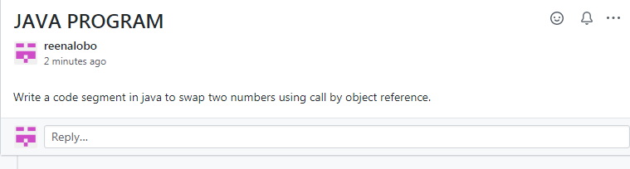

STUDENTS REPORT:

Ravali:

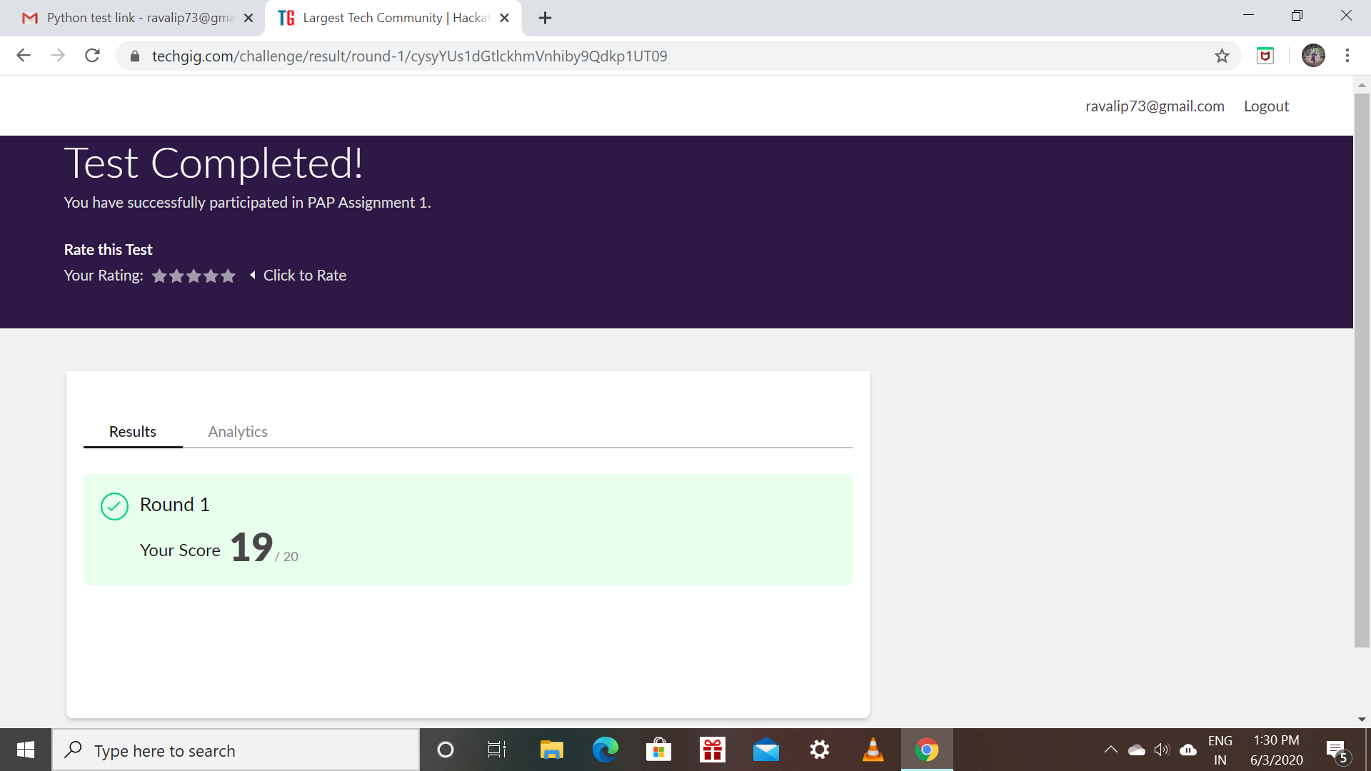

Certification Course Details: (Attach the snapshot and briefly write the report for the same)

* Todays topic is about loops,Functions,Objects and Classes.

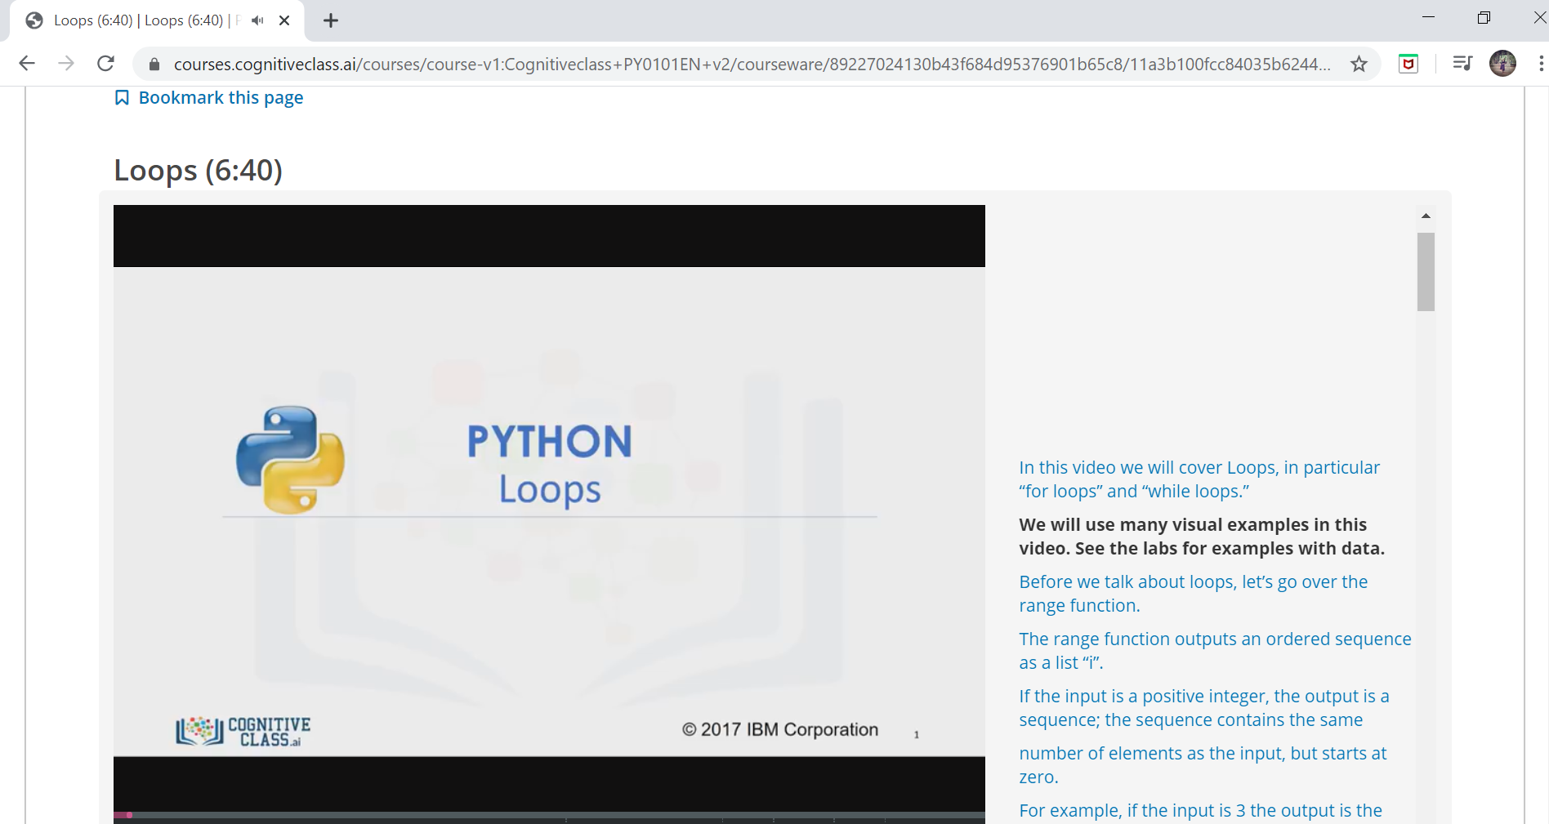

Raksha:

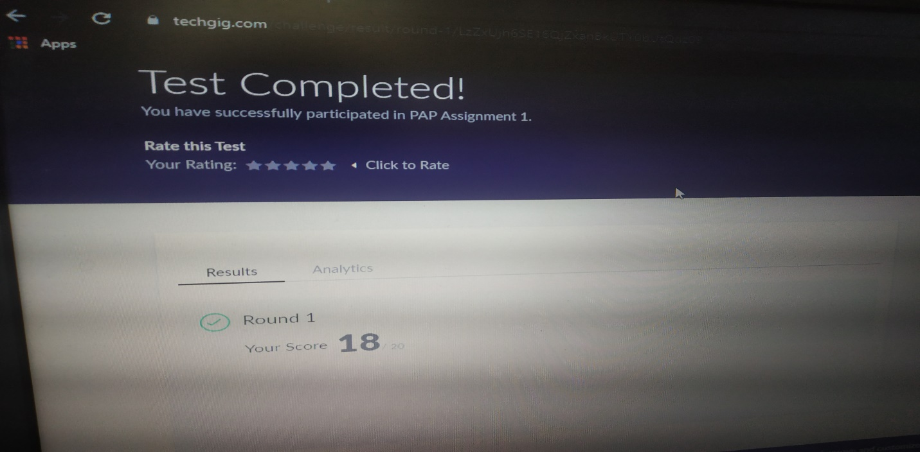

Scored 18 out of 20 in Python Assignment test

Certification Course Details:

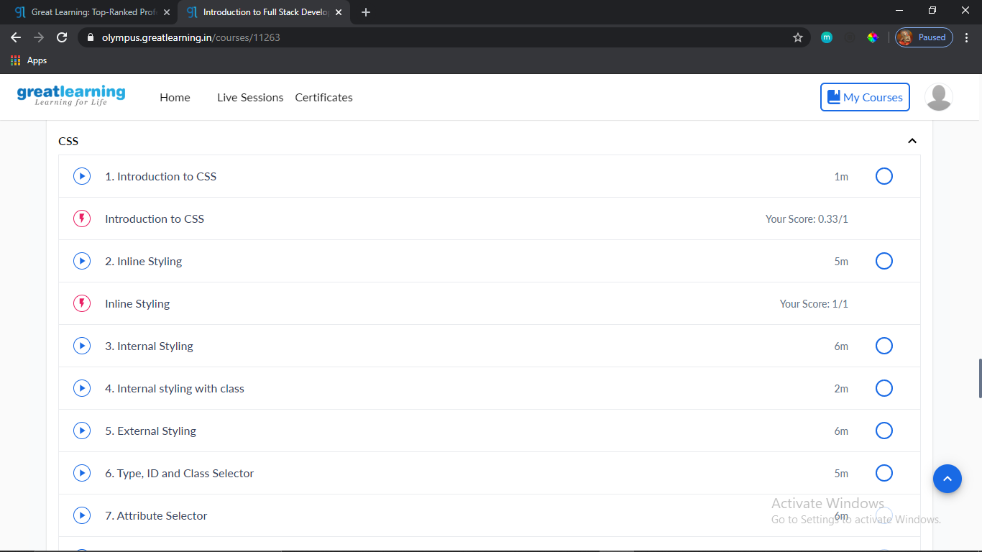

Rohan mahaveer:

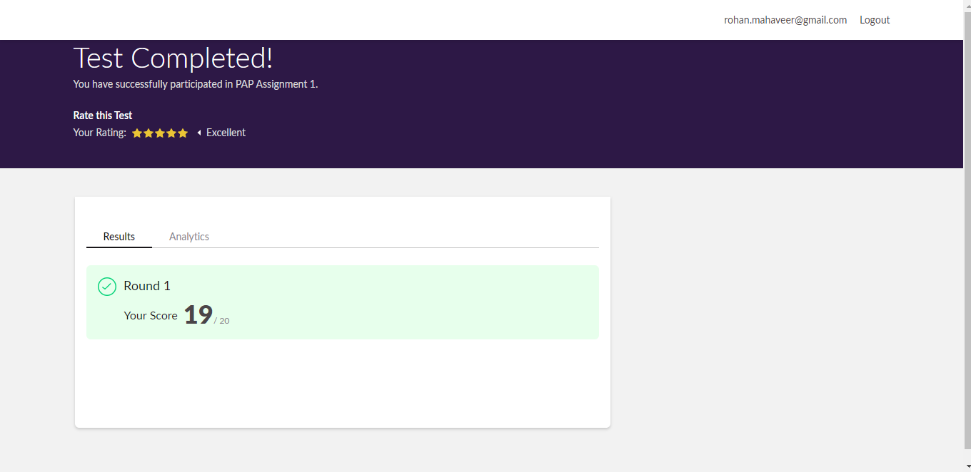

Scored 19 out of 20 in Python Assignment test

Certification Course Details:

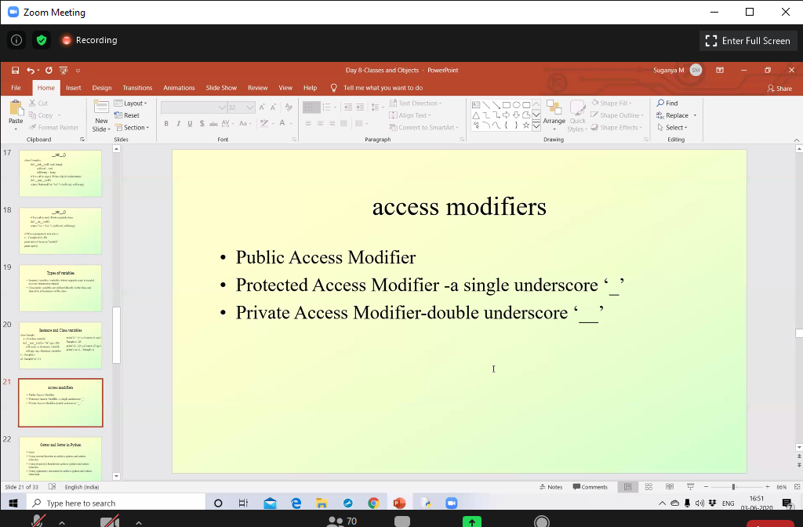

Today in certification I have attended online python session in EBOX as mentioned above. I learnt about classes and objects in that access modifier, Types of variables etc.

Coding Challenges Details:

Program1:

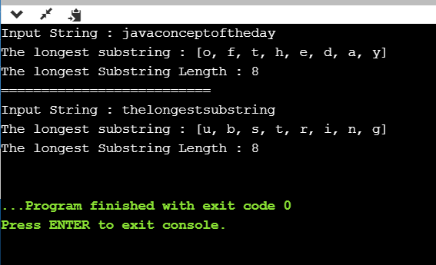

Preethi:

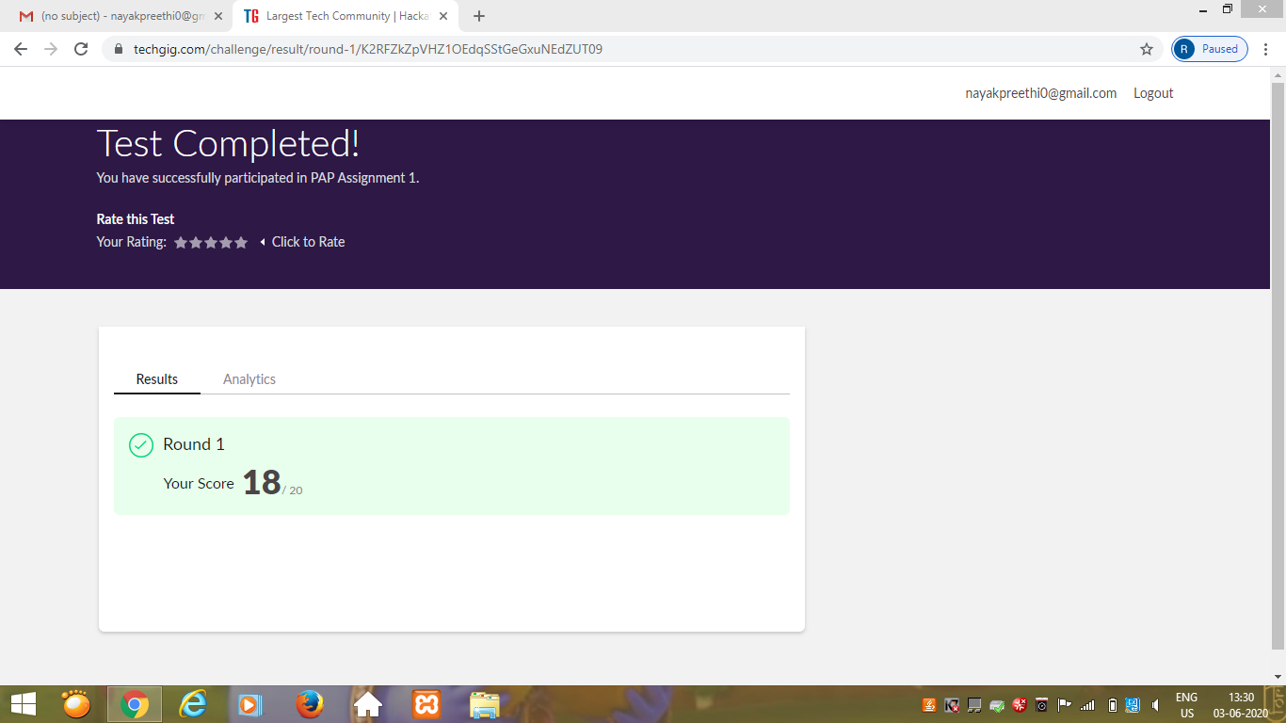

Certification Course Details: (Attach the snapshot and briefly write the report for the same)

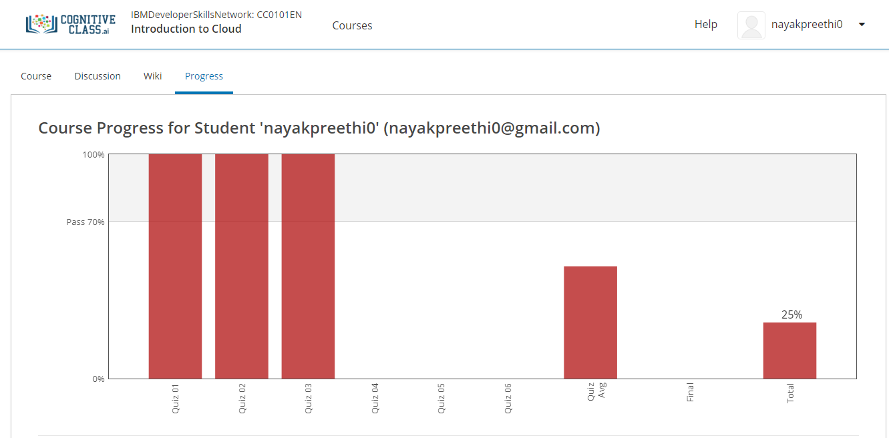

Today I completed module 3 –“Cloud computing Service and Deployment Models”

In this I learnt,

1. Introduction and Objectives of this module.

2.Overview of Service models.

3.IaaS(Infrastructure as a Sevice),PaaS(Platform as a Service),SaaS(Software as a Service).

4.Public Cloud,Private Cloud and Hybrid Cloud.

Pranav:

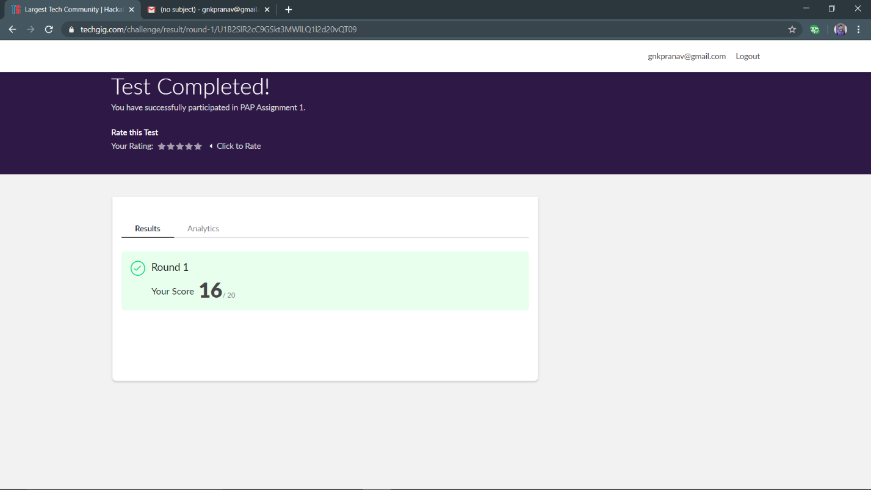

CERTIFICATION DETAILS

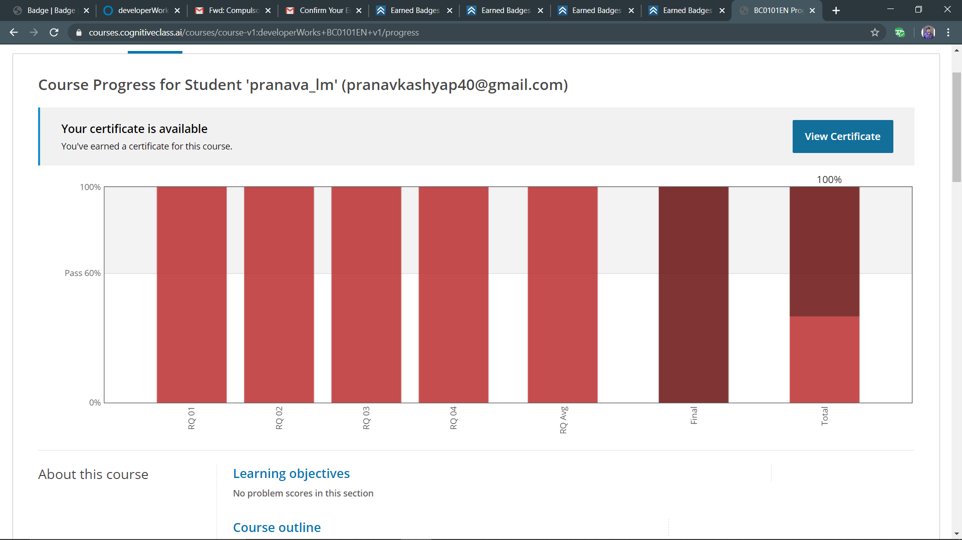

Rachana:

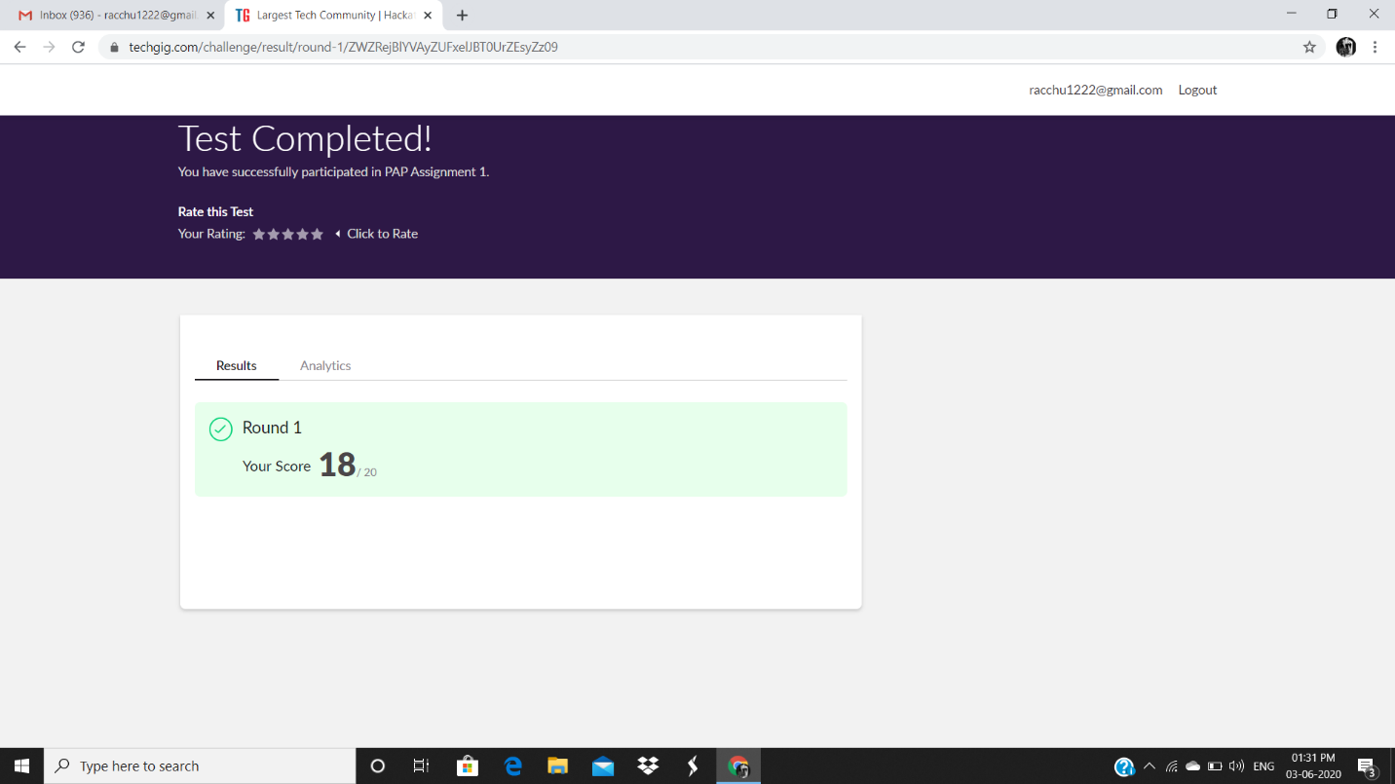

**Certification Course Details:**

**Today Progress:**

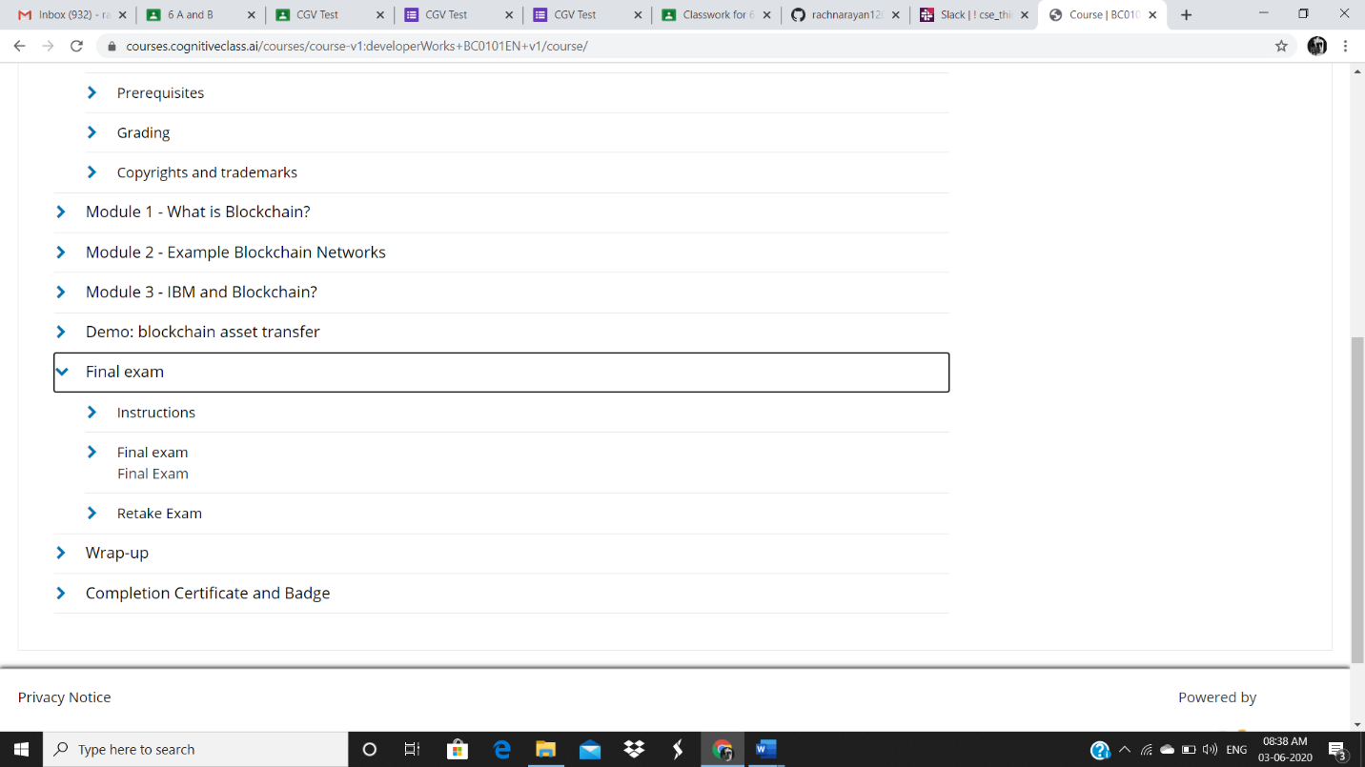

**Coding Challenges Details:**

Refer the github link for detail information : https://github.com/rachnarayan1201/daily_status_coding/commits?author=rachnarayan1201

Solved all the problems and the solutions are uploaded in github account.

**Priyanka:**

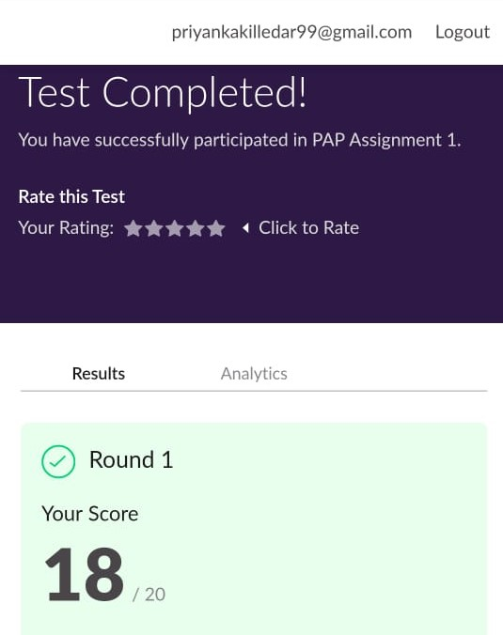

**Certification Course Details:**

**Today Progress:**

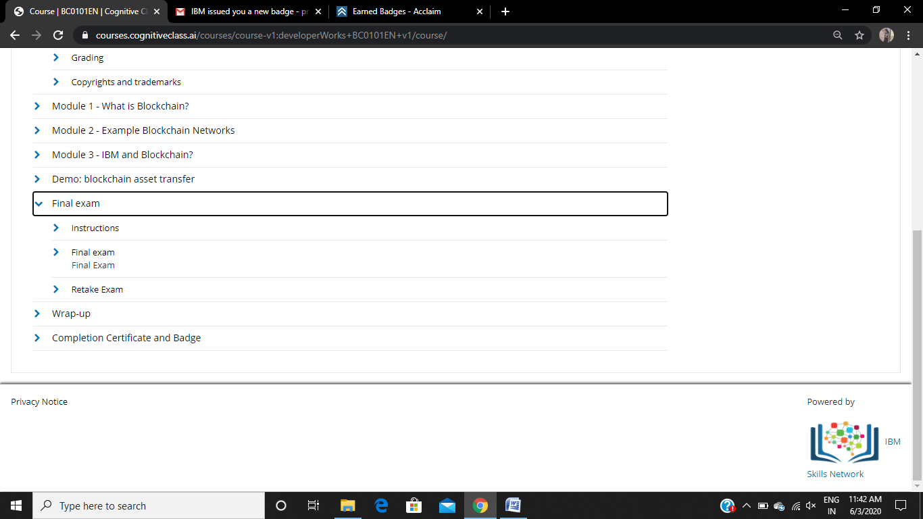

**Completed the final exam and the below screen shot is the progress**

**Rani:**

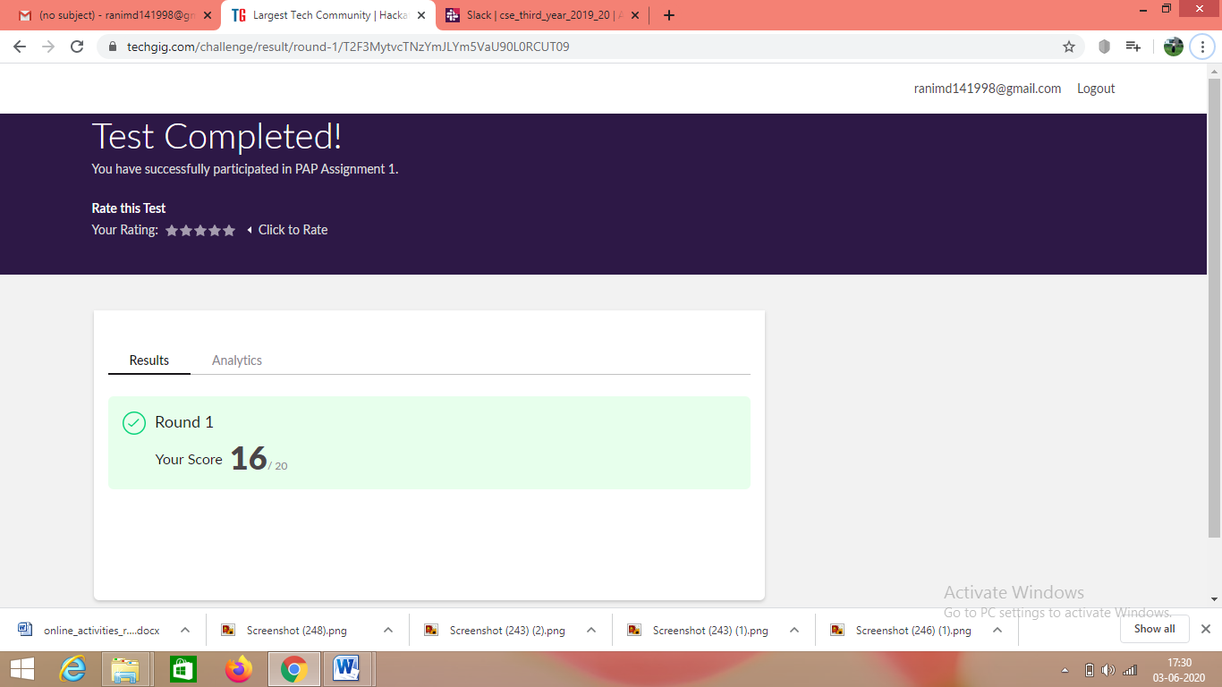

Certification course details:

1.

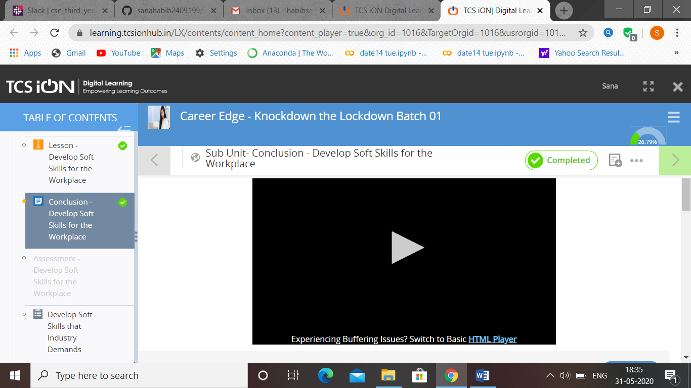

2.

**Sana:**

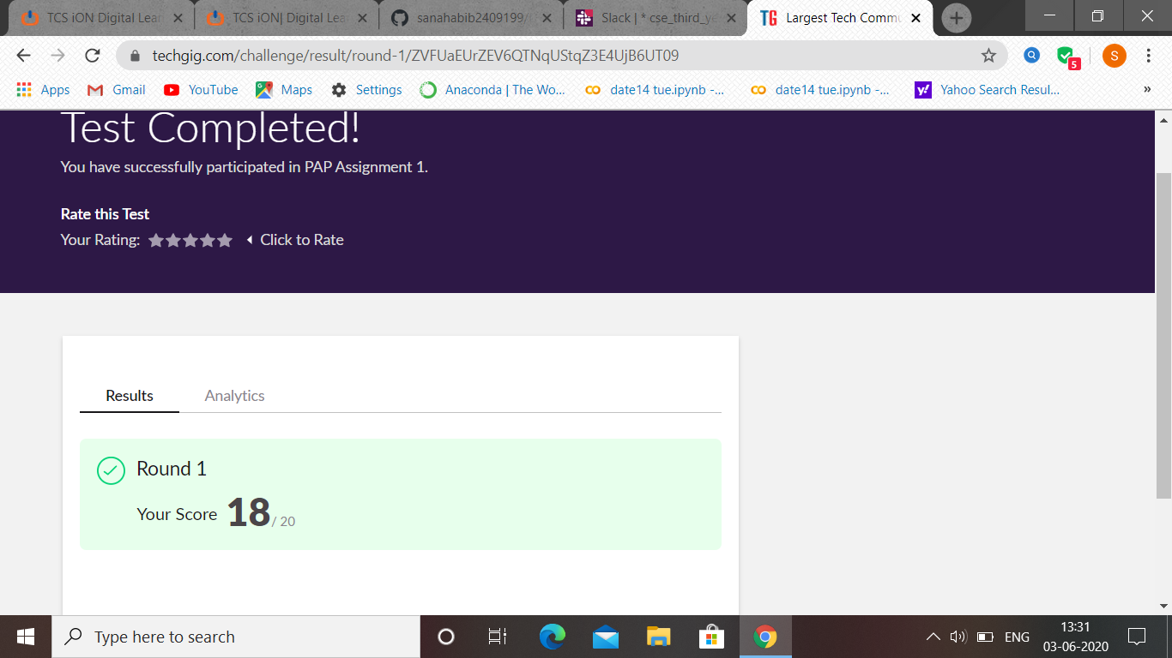

PAP assignment 1 test was held today. i.e 3 June 2020. Out of 20 marks I scored 18.

Certification Course Details: (Attach the snapshot and briefly write the report for the same

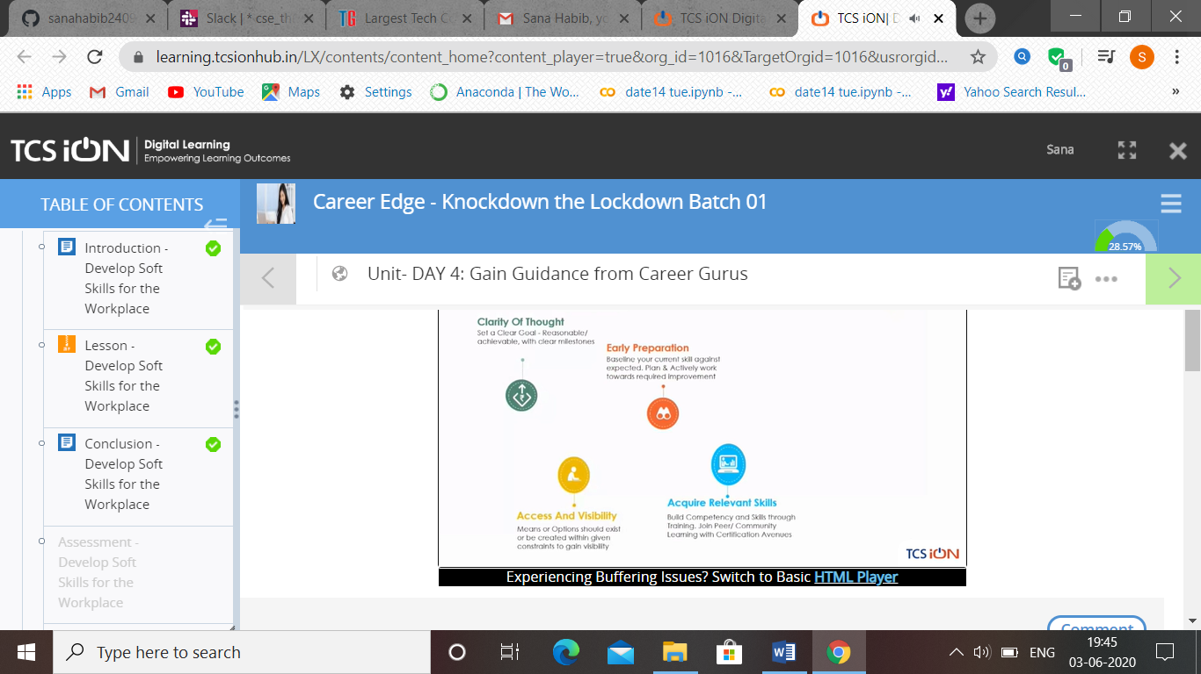

**Atish:**

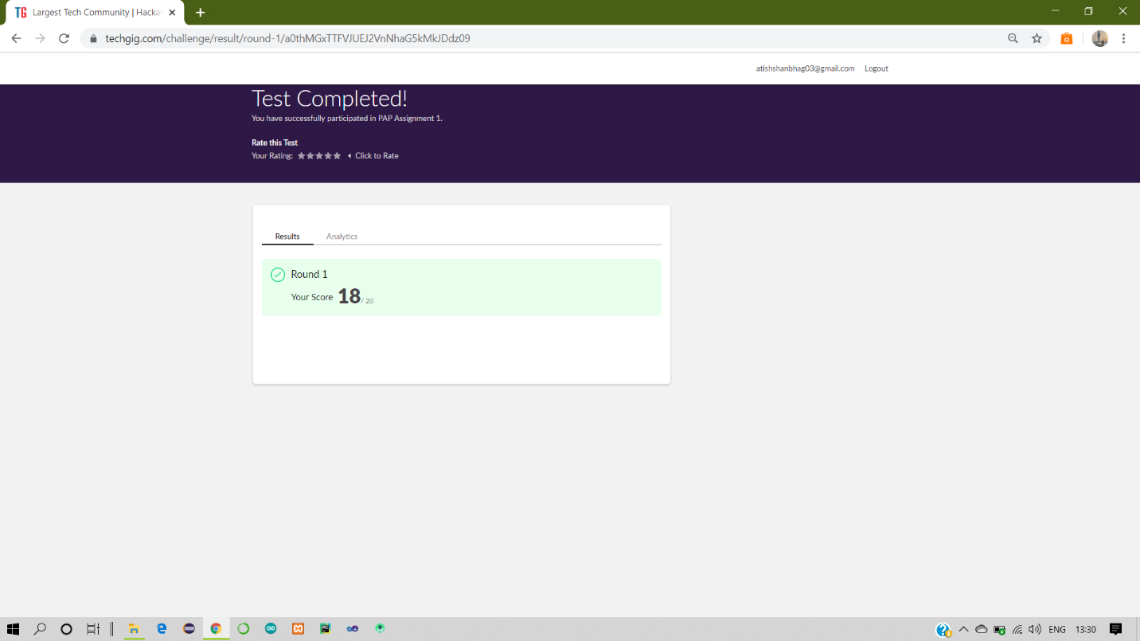

Certification Course Details:

Report

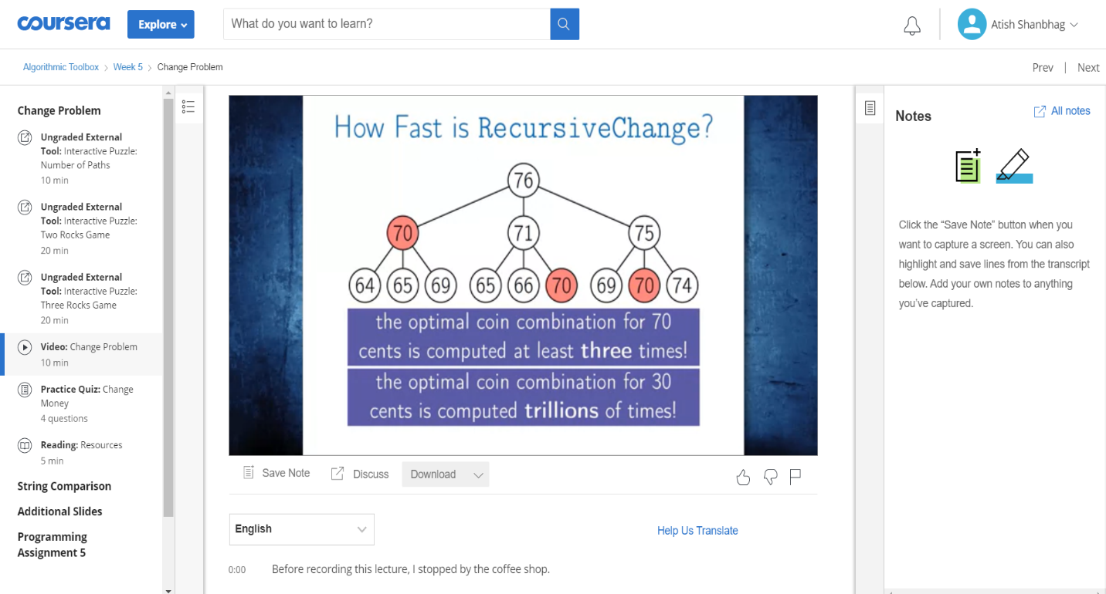

**Dhruvil:**

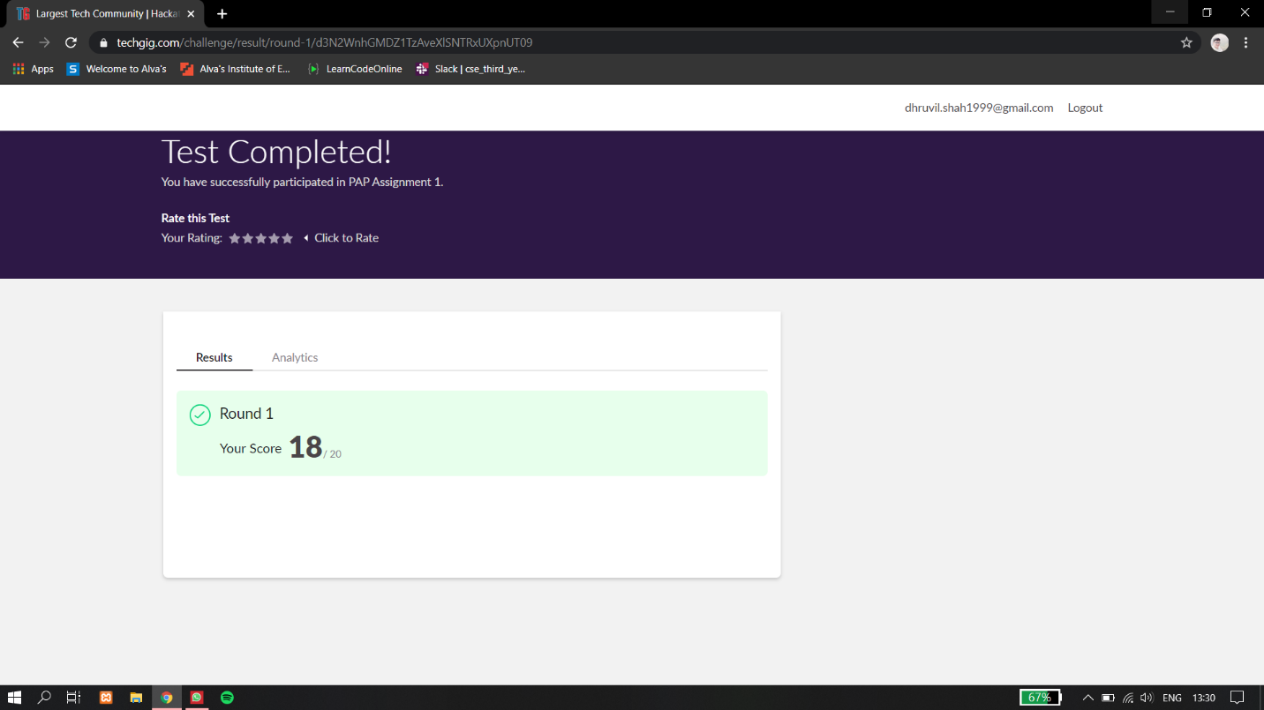

Certification Course Details:

Report

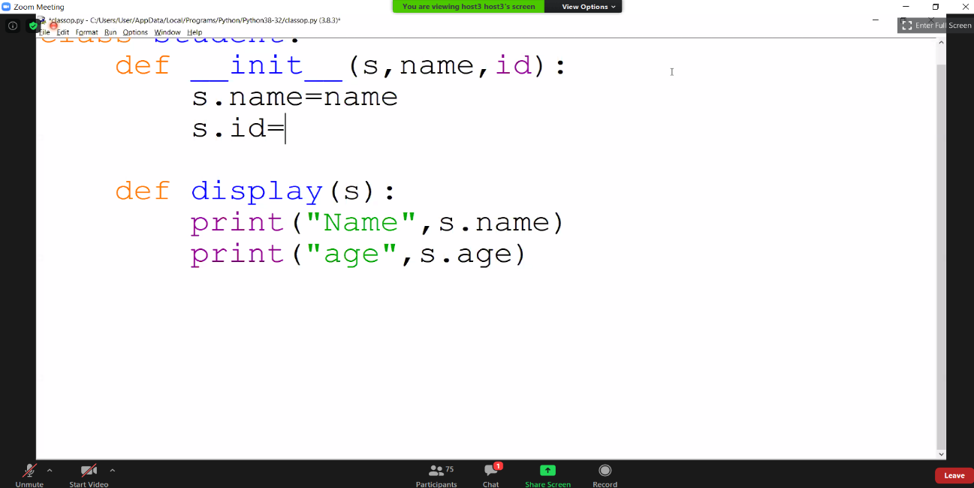

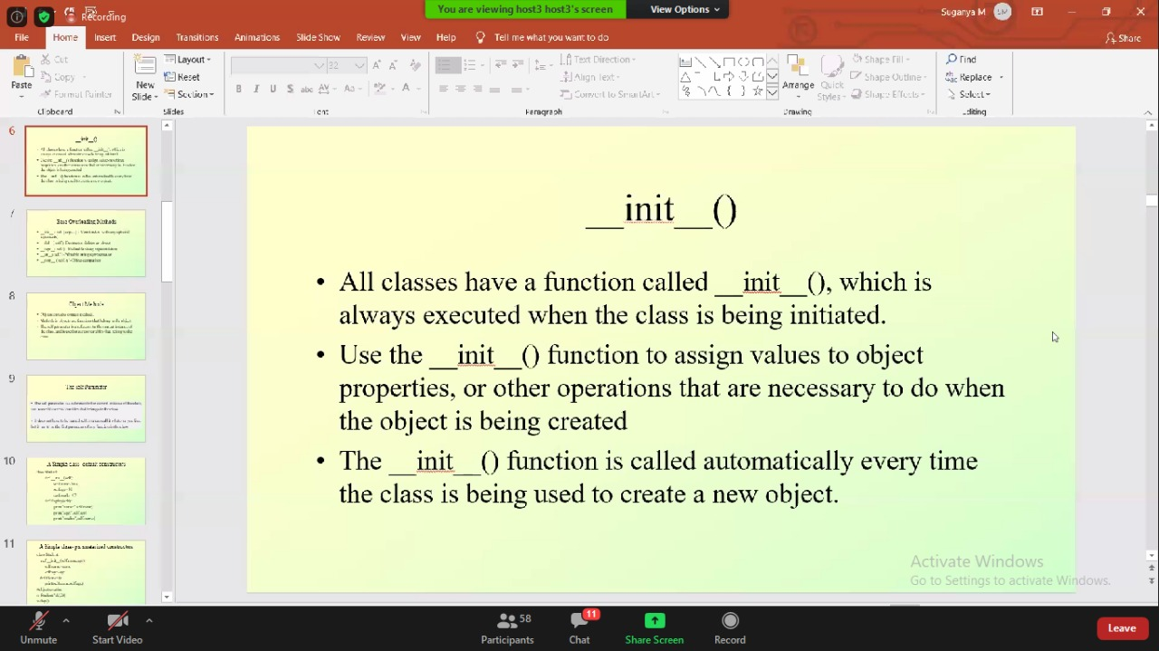

**Rohan vasista:**

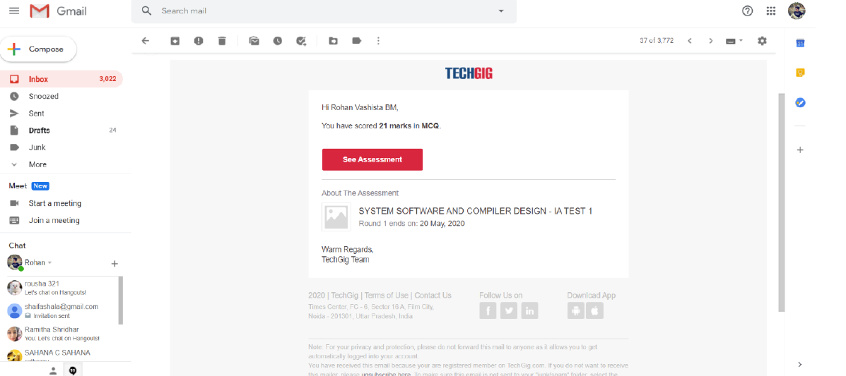

**Priya h t:**

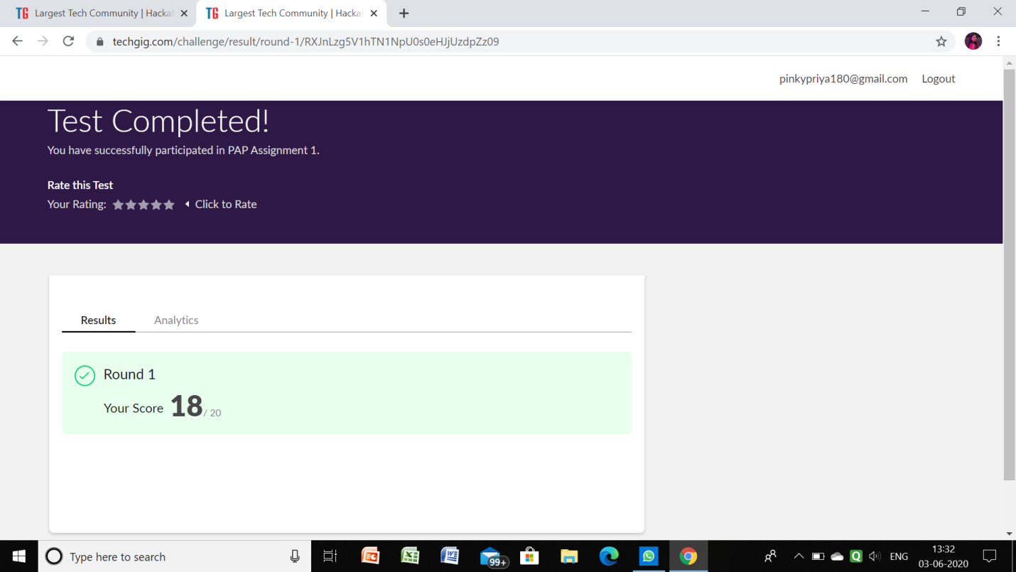

**Certification Course Details:**

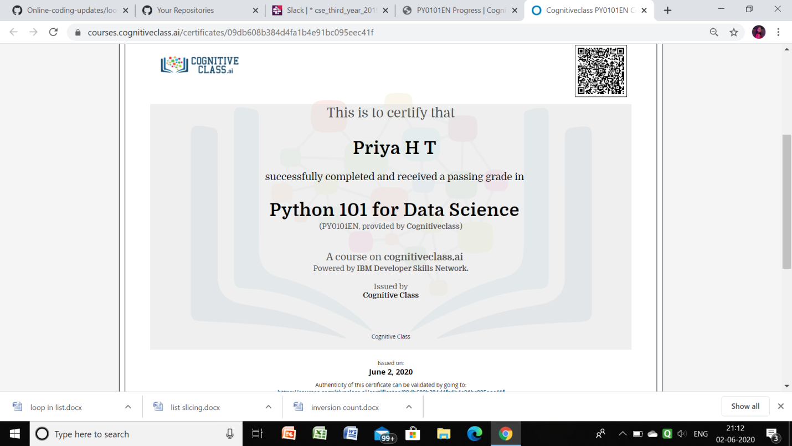

**Raghavi:**

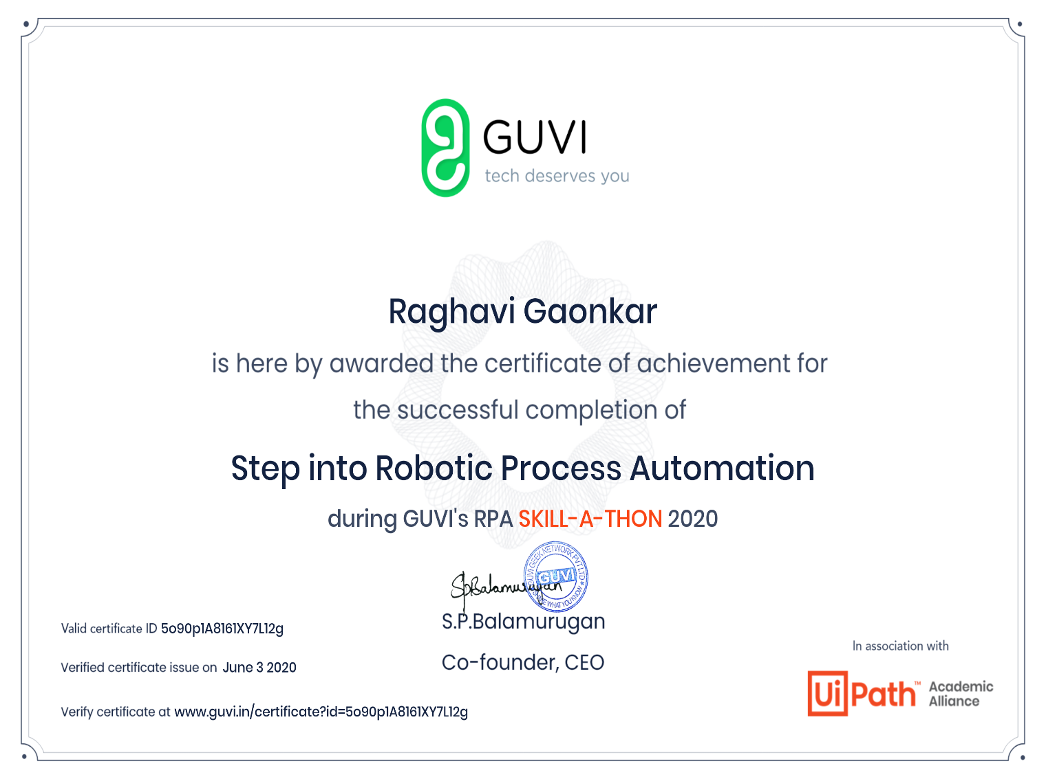

**Sachin:**

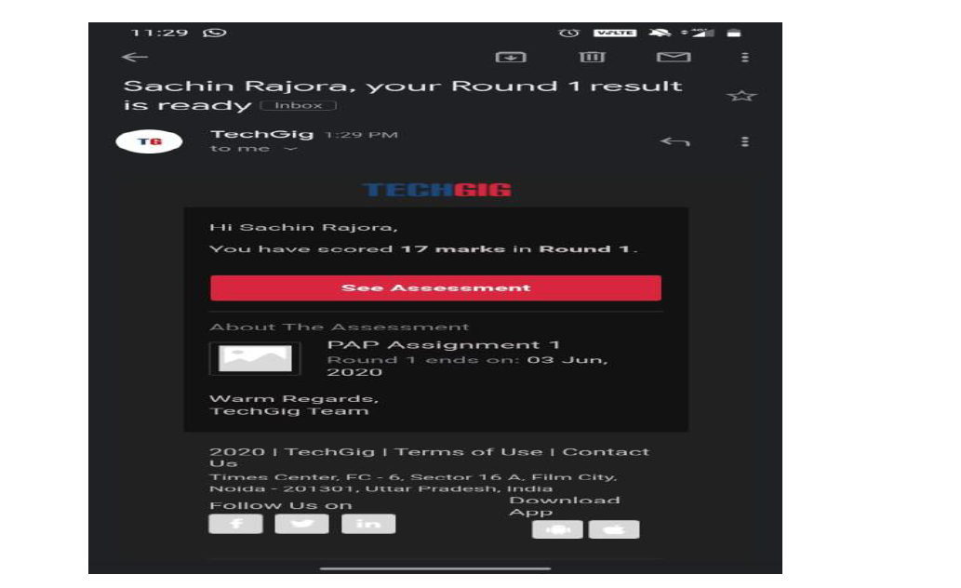

Rousha:

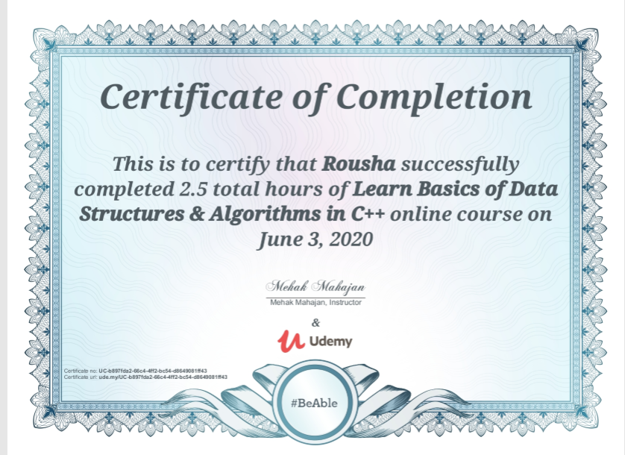

Shaifa:

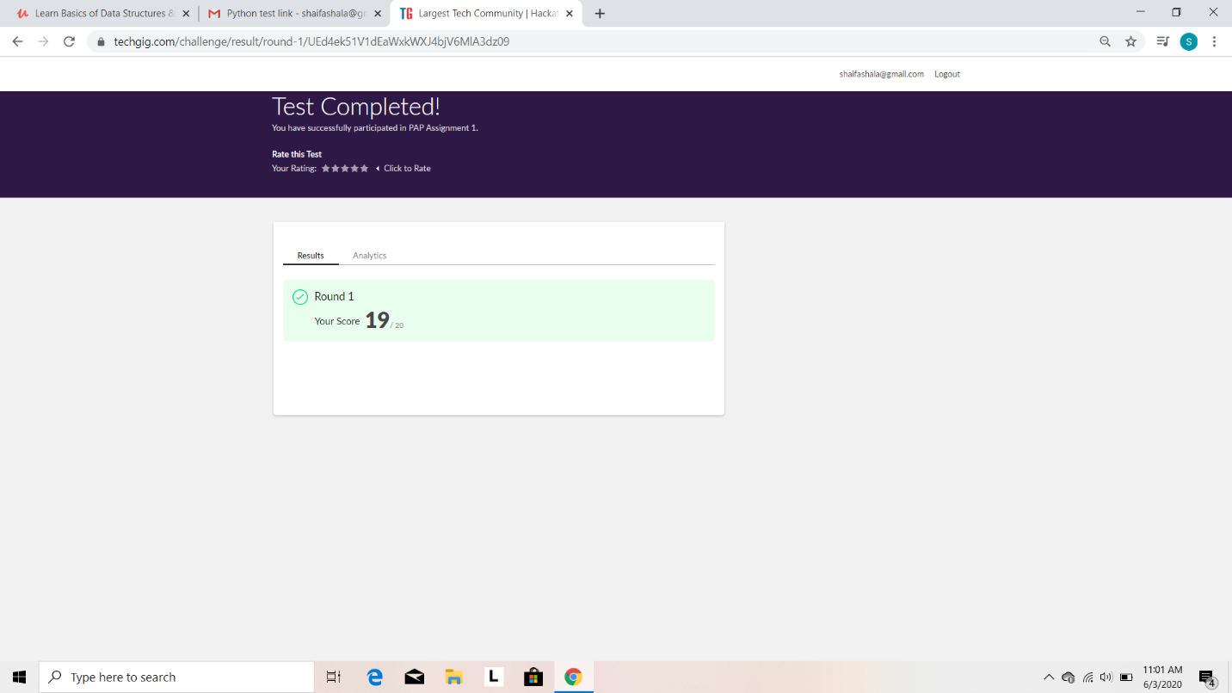

Certification Course Details: (Attach the snapshot and briefly write the report for the same)

Completed the course “Learn basics of data structures and algorithms in C++” and obtained a certificate.Posted both of then in github repository.

Certificate:

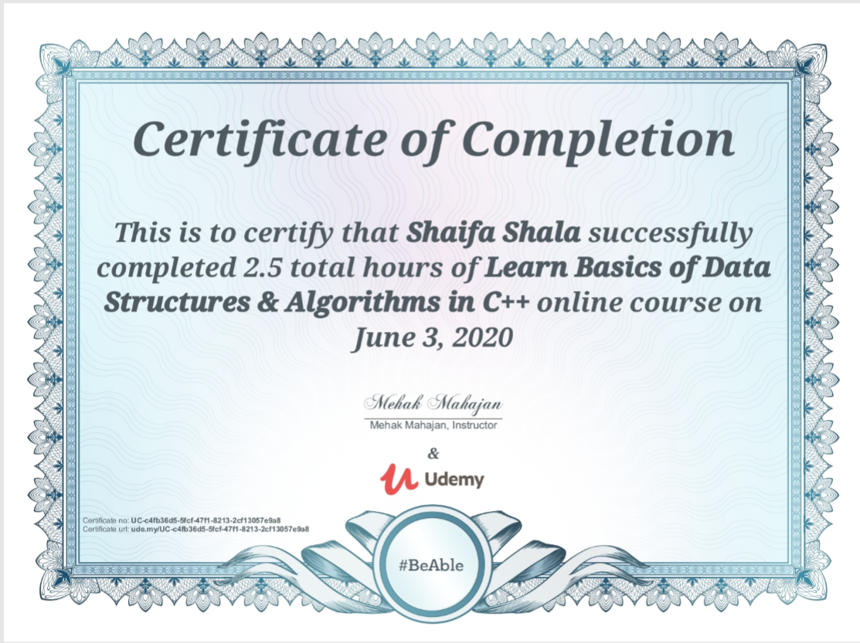

Coding Challenges Details: (Attach the snapshot and briefly write the